19)

#include <stdio.h>

#include <pthread.h>

#define NUM_THREADS 5

pthread_mutex_t lock;

void* threadFunction(void* arg) {

pthread_mutex_lock(&lock);

printf("Thread %d is in the critical section.\n", *(int*)arg);

pthread_mutex_unlock(&lock);

return NULL;

}

int main() {

pthread_t threads[NUM_THREADS];

int threadIds[NUM_THREADS];

pthread_mutex_init(&lock, NULL);

for (int i = 0; i < NUM_THREADS; i++) {

threadIds[i] = i;

pthread_create(&threads[i], NULL, threadFunction, &threadIds[i]);

}

for (int i = 0; i < NUM_THREADS; i++) {

pthread_join(threads[i], NULL);

}

pthread_mutex_destroy(&lock);

return 0;

}

**OUTPUT:**

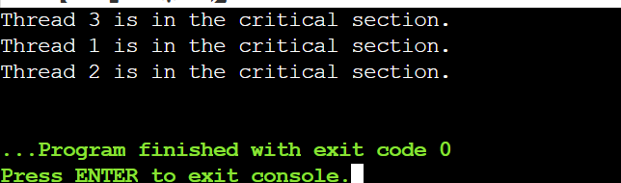

20)

#include <stdio.h>

#include <stdlib.h>

#include <pthread.h>

#include <semaphore.h>

#include <unistd.h>

#define READERS 5

#define WRITERS 2

sem_t mutex, writeBlock;

int readCount = 0;

void* reader(void* arg) {

int id = *(int*)arg;

while (1) {

sem_wait(&mutex);

readCount++;

if (readCount == 1) sem_wait(&writeBlock);

sem_post(&mutex);

printf("Reader %d is reading.\n", id);

sleep(1);

sem_wait(&mutex);

readCount--;

if (readCount == 0) sem_post(&writeBlock);

sem_post(&mutex);

sleep(1);

}

return NULL;

}

void* writer(void* arg) {

int id = *(int*)arg;

while (1) {

sem_wait(&writeBlock);

printf("Writer %d is writing.\n", id);

sleep(2);

sem_post(&writeBlock);

sleep(1);

}

return NULL;

}

int main() {

pthread_t r[READERS], w[WRITERS];

int ids[READERS + WRITERS];

sem_init(&mutex, 0, 1);

sem_init(&writeBlock, 0, 1);

for (int i = 0; i < READERS; i++) {

ids[i] = i + 1;

pthread_create(&r[i], NULL, reader, &ids[i]);

}

for (int i = 0; i < WRITERS; i++) {

ids[READERS + i] = i + 1;

pthread_create(&w[i], NULL, writer, &ids[READERS + i]);

}

for (int i = 0; i < READERS; i++) pthread_join(r[i], NULL);

for (int i = 0; i < WRITERS; i++) pthread_join(w[i], NULL);

sem_destroy(&mutex);

sem_destroy(&writeBlock);

return 0;

}

**OUT PUT:**

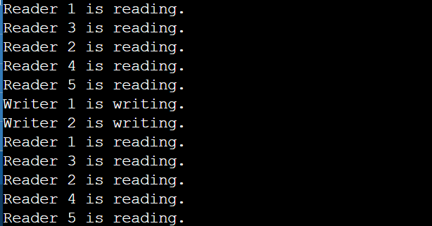

21)

#include <stdio.h>

int main() {

int blockSize[] = {100, 500, 200, 300, 600};

int processSize[] = {212, 417, 112, 426};

int n = sizeof(blockSize) / sizeof(blockSize[0]);

int m = sizeof(processSize) / sizeof(processSize[0]);

int allocation[m];

for (int i = 0; i < m; i++) {

int worstIdx = -1;

for (int j = 0; j < n; j++) {

if (blockSize[j] >= processSize[i]) {

if (worstIdx == -1 || blockSize[j] > blockSize[worstIdx])

worstIdx = j;

}

}

if (worstIdx != -1) {

allocation[i] = worstIdx;

blockSize[worstIdx] -= processSize[i];

} else {

allocation[i] = -1;

}

}

for (int i = 0; i < m; i++)

printf("Process %d allocated to Block %d\n", i + 1, allocation[i] + 1);

return 0;

}

**OUT PUT:**

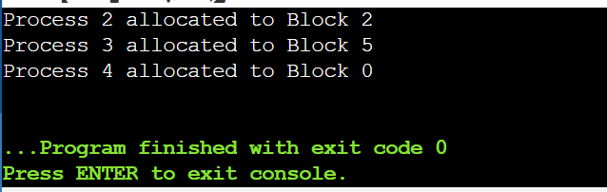

22)

#include <stdio.h>

int main() {

int blockSize[] = {100, 500, 200, 300, 600};

int processSize[] = {212, 417, 112, 426};

int n = sizeof(processSize) / sizeof(processSize[0]);

int m = sizeof(blockSize) / sizeof(blockSize[0]);

int allocation[n];

for (int i = 0; i < n; i++) {

int bestIdx = -1;

for (int j = 0; j < m; j++) {

if (blockSize[j] >= processSize[i]) {

if (bestIdx == -1 || blockSize[bestIdx] > blockSize[j])

bestIdx = j;

}

}

if (bestIdx != -1) {

allocation[i] = bestIdx;

blockSize[bestIdx] -= processSize[i];

} else {

allocation[i] = -1;

}

}

printf("Process No.\tProcess Size\tBlock No.\n");

for (int i = 0; i < n; i++) {

printf("%d\t\t%d\t\t", i + 1, processSize[i]);

if (allocation[i] != -1)

printf("%d\n", allocation[i] + 1);

else

printf("Not Allocated\n");

}

return 0;

}

**OUTP UT:**

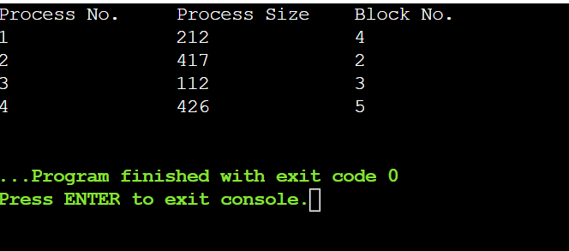

23)

#include <stdio.h>

int main() {

int blockSize[] = {100, 500, 200, 300, 600};

int processSize[] = {212, 417, 112, 426};

int n = sizeof(processSize) / sizeof(processSize[0]);

int m = sizeof(blockSize) / sizeof(blockSize[0]);

int allocation[n];

for (int i = 0; i < n; i++) {

allocation[i] = -1;

for (int j = 0; j < m; j++) {

if (blockSize[j] >= processSize[i]) {

allocation[i] = j;

blockSize[j] -= processSize[i];

break;

}

}

}

printf("Process No.\tBlock No.\n");

for (int i = 0; i < n; i++)

printf(" %d\t\t%d\n", i + 1, allocation[i] + 1);

return 0;

}

**OUT PUT:**

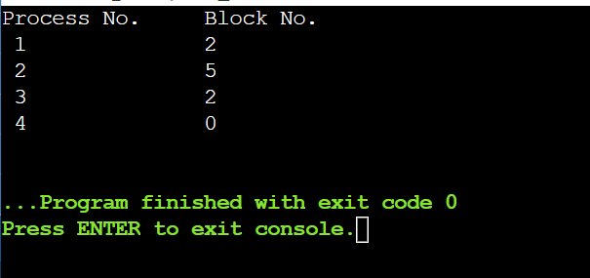

24)

#include <stdio.h>

#include <stdlib.h>

#include <unistd.h>

#include <fcntl.h>

int main() {

int fd;

char *text = "Hello, UNIX System Calls!\n";

char buffer[50];

fd = open("example.txt", O_CREAT | O_WRONLY, 0644);

write(fd, text, 30);

close(fd);

fd = open("example.txt", O_RDONLY);

read(fd, buffer, 30);

printf("%s", buffer);

close(fd);

unlink("example.txt");

return 0;

}

**OUT PUT:**

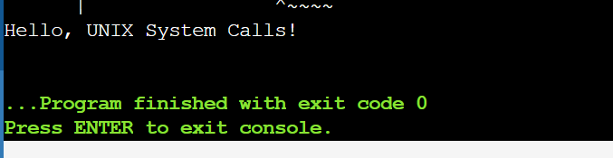

25)

#include <stdio.h>

#include <fcntl.h>

#include <unistd.h>

#include <sys/stat.h>

#include <dirent.h>

int main() {

int fd = open("example.txt", O_RDWR | O_CREAT, 0644);

fcntl(fd, F_SETFL, O_NONBLOCK);

lseek(fd, 0, SEEK_SET);

struct stat fileStat;

stat("example.txt", &fileStat);

printf("File size: %ld bytes\n", fileStat.st_size);

DIR *dir = opendir(".");

struct dirent *entry;

while ((entry = readdir(dir)) != NULL) {

printf("Found: %s\n", entry->d_name);

}

closedir(dir);

close(fd);

return 0;

}

**OUT PUT:**

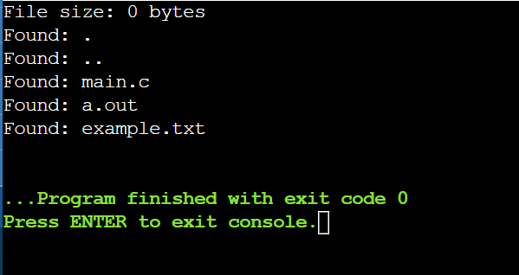

**26)**

#include <stdio.h>

#include <stdlib.h>

void createFile(const char *filename) {

FILE *file = fopen(filename, "w");

if (file) fclose(file);

}

void writeFile(const char *filename, const char *content) {

FILE *file = fopen(filename, "a");

if (file) {

fputs(content, file);

fclose(file);

}

}

void readFile(const char *filename) {

char buffer[100];

FILE *file = fopen(filename, "r");

if (file) {

while (fgets(buffer, sizeof(buffer), file)) {

printf("%s", buffer);

}

fclose(file);

}

}

void deleteFile(const char *filename) {

remove(filename);

}

int main() {

const char *filename = "example.txt";

createFile(filename);

writeFile(filename, "Hello, World!\n");

readFile(filename);

deleteFile(filename);

return 0;

}

**OUT PUT:**

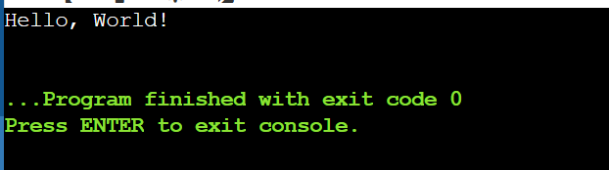

**27)**

#include <stdio.h>

#include <dirent.h>

int main() {

struct dirent *entry;

DIR *dp = opendir(".");

if (dp == NULL) {

perror("opendir");

return 1;

}

while ((entry = readdir(dp)) != NULL) {

printf("%s\n", entry->d_name);

}

closedir(dp);

return 0;

}

OUT PUT:

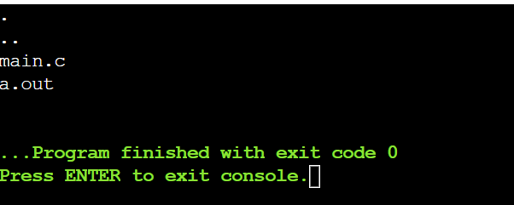

28)

#include <stdio.h>

#include <string.h>

int main(int argc, char *argv[]) {

if (argc != 3) {

printf("Usage: %s <pattern> <file>\n", argv[0]);

return 1;

}

FILE *file = fopen(argv[2], "r");

if (!file) {

perror("File opening failed");

return 1;

}

char line[256];

while (fgets(line, sizeof(line), file)) {

if (strstr(line, argv[1])) {

printf("%s", line);

}

}

fclose(file);

return 0;

}

OUT PUT:

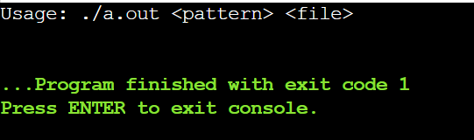

29)

#include <stdio.h>

#include <stdlib.h>

#include <pthread.h>

#include <semaphore.h>

#include <unistd.h>

#define NUM_THREADS 5

sem_t semaphore;

void* threadFunction(void* arg) {

int id = *((int*)arg);

sem_wait(&semaphore);

printf("Thread %d is in the critical section.\n", id);

sleep(1);

printf("Thread %d is leaving the critical section.\n", id);

sem_post(&semaphore);

return NULL;

}

int main() {

pthread_t threads[NUM_THREADS];

int thread_ids[NUM_THREADS];

sem_init(&semaphore, 0, 1);

for (int i = 0; i < NUM_THREADS; i++) {

thread_ids[i] = i + 1;

pthread_create(&threads[i], NULL, threadFunction, &thread_ids[i]);

}

for (int i = 0; i < NUM_THREADS; i++) {

pthread_join(threads[i], NULL);

}

sem_destroy(&semaphore);

return 0;

}

**OUT PUT:**

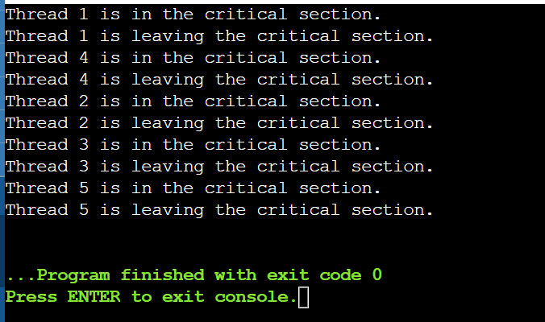

**30)**

1.

#include <stdio.h>

#include <pthread.h>

void* printMessage(void* msg) {

printf("%s\n", (char*)msg);

return NULL;

}

int main() {

pthread_t thread;

char* message = "Hello from the thread!";

pthread_create(&thread, NULL, printMessage, (void*)message);

pthread_join(thread, NULL);

return 0;

}

OUT PUT:

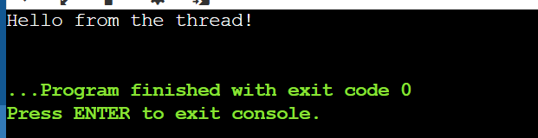

2)

#include <stdio.h>

#include <pthread.h>

int counter = 0;

pthread_mutex_t lock;

void* incrementCounter(void* arg) {

pthread_mutex_lock(&lock);

counter++;

pthread_mutex_unlock(&lock);

return NULL;

}

int main() {

pthread_t threads[5];

pthread_mutex_init(&lock, NULL);

for (int i = 0; i < 5; i++) pthread_create(&threads[i], NULL, incrementCounter, NULL);

for (int i = 0; i < 5; i++) pthread_join(threads[i], NULL);

printf("Counter: %d\n", counter);

pthread_mutex_destroy(&lock);

return 0;

}

OUT PUT:

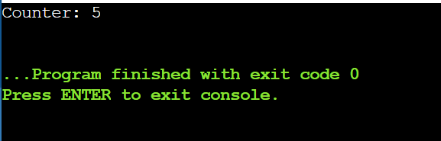

3)

#include <stdio.h>

#include <pthread.h>

#include <unistd.h>

void* run(void* arg) {

while (1) {

printf("Thread running...\n");

sleep(1);

}

return NULL;

}

int main() {

pthread_t thread;

pthread_create(&thread, NULL, run, NULL);

sleep(3);

pthread_cancel(thread);

pthread_join(thread, NULL);

printf("Thread terminated.\n");

return 0;

}

OUT PUT:

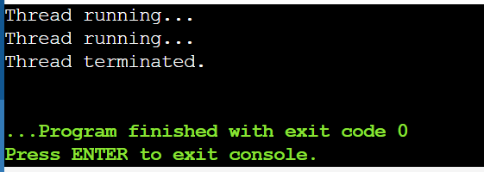

31)

#include <stdio.h>

#define FRAME_SIZE 3

#define PAGE_COUNT 5

int main() {

int pages[PAGE_COUNT] = {0, 1, 2, 3, 4};

int frames[FRAME_SIZE] = {-1, -1, -1};

int pageFaults = 0, i, j, k;

for (i = 0; i < PAGE_COUNT; i++) {

int found = 0;

for (j = 0; j < FRAME_SIZE; j++) {

if (frames[j] == pages[i]) {

found = 1; break;

}

}

if (!found) {

frames[pageFaults % FRAME_SIZE] = pages[i];

pageFaults++;

}

printf("Page: %d | Frames: ", pages[i]);

for (k = 0; k < FRAME_SIZE; k++) printf("%d ", frames[k]);

printf("\n");

}

printf("Total Page Faults: %d\n", pageFaults);

return 0;

}

OUT PUT:

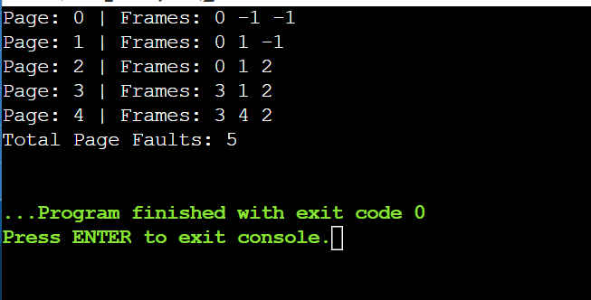

32)

#include <stdio.h>

int main() {

int pages[10], frame[3], n, m, i, j, k, pos, flag, pageFaults = 0;

printf("Enter number of pages: ");

scanf("%d", &n);

printf("Enter pages: ");

for (i = 0; i < n; i++) scanf("%d", &pages[i]);

for (i = 0; i < 3; i++) frame[i] = -1;

for (i = 0; i < n; i++) {

flag = 0;

for (j = 0; j < 3; j++) if (frame[j] == pages[i]) flag = 1;

if (!flag) {

pageFaults++;

pos = -1;

for (j = 0; j < 3; j++) {

if (frame[j] == -1) { pos = j; break; }

for (k = i - 1; k >= 0; k--) if (frame[j] == pages[k]) { pos = j; break; }

}

if (pos == -1) pos = 0;

frame[pos] = pages[i];

}

}

printf("Page Faults: %d\n", pageFaults);

return 0;

}

OUT PUT:

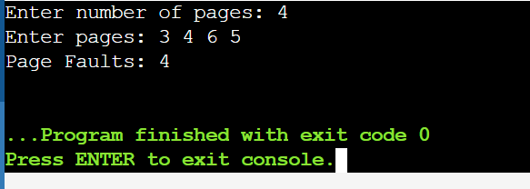

33)

#include <stdio.h>

int main() {

int pages[] = {0, 1, 2, 0, 3, 0, 4, 2, 3, 0, 3, 2};

int frames[3] = {-1, -1, -1}, pageFaults = 0, n = 12, f = 3;

for (int i = 0; i < n; i++) {

int j, found = 0;

for (j = 0; j < f; j++) if (frames[j] == pages[i]) found = 1;

if (!found) {

int replace = -1, farthest = -1;

for (j = 0; j < f; j++) {

int k;

for (k = i + 1; k < n; k++) {

if (frames[j] == pages[k]) break;

}

if (k > farthest) { farthest = k; replace = j; }

}

frames[replace] = pages[i];

pageFaults++;

}

}

printf("Page Faults: %d\n", pageFaults);

return 0;

}

OUT PUT:

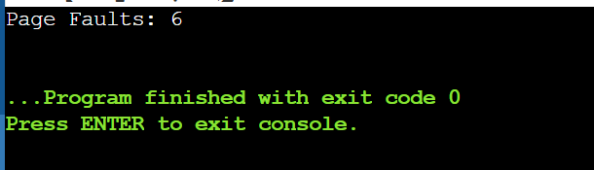

34)

#include <stdio.h>

#define MAX_RECORDS 100

void readRecords(char records[MAX_RECORDS][50], int count) {

for (int i = 0; i < count; i++) {

printf("Record %d: %s\n", i + 1, records[i]);

}

}

int main() {

char records[MAX_RECORDS][50] = {

"Record 1: Data A",

"Record 2: Data B",

"Record 3: Data C"

};

int count = 3;

readRecords(records, count);

return 0;

}

OUT PUT:

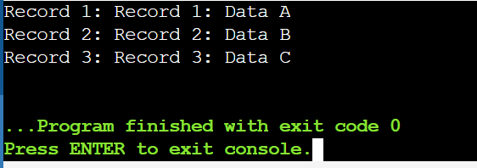

35)

#include <stdio.h>

#include <stdlib.h>

#define BLOCKS 5

typedef struct {

int block[BLOCKS];

} IndexBlock;

void allocateFile(IndexBlock *index) {

for (int i = 0; i < BLOCKS; i++) {

index->block[i] = i + 1;

}

}

void displayAllocation(IndexBlock *index) {

printf("File Allocation:\n");

for (int i = 0; i < BLOCKS; i++) {

printf("Index %d -> Block %d\n", i, index->block[i]);

}

}

int main() {

IndexBlock index;

allocateFile(&index);

displayAllocation(&index);

return 0;

}

**OUT PUT:**

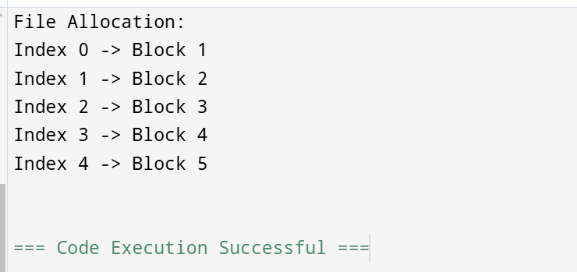

36)

#include <stdio.h>

#include <stdlib.h>

typedef struct Block {

int data;

struct Block* next;

} Block;

typedef struct File {

Block* head;

Block* tail;

} File;

File* createFile() {

File* f = malloc(sizeof(File));

f->head = f->tail = NULL;

return f;

}

void addBlock(File* f, int data) {

Block* b = malloc(sizeof(Block));

b->data = data;

b->next = NULL;

if (!f->head) f->head = f->tail = b;

else f->tail->next = b, f->tail = b;

}

void displayFile(File* f) {

for (Block* b = f->head; b; b = b->next)

printf("%d -> ", b->data);

printf("NULL\n");

}

int main() {

File* myFile = createFile();

addBlock(myFile, 1);

addBlock(myFile, 2);

addBlock(myFile, 3);

displayFile(myFile);

return 0;

}

**OUT PUT:**

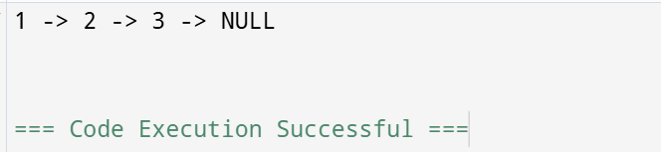

37)

#include <stdio.h>

#include <stdlib.h>

void FCFS(int arr[], int n, int head) {

int total_head_movement = 0;

for (int i = 0; i < n; i++) {

total_head_movement += abs(arr[i] - head);

head = arr[i];

}

printf("Total head movement: %d\n", total_head_movement);

}

int main() {

int requests[] = {176, 79, 34, 60, 92, 11, 41, 114};

int n = sizeof(requests) / sizeof(requests[0]);

int initial_head = 50;

FCFS(requests, n, initial_head);

return 0;

}

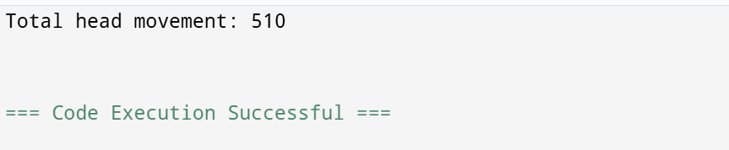

38)

#include <stdio.h>

#include <stdlib.h>

int main() {

int requests[] = {176, 79, 34, 60, 92, 11, 41, 114};

int head = 50, total_head_movement = 0, size = sizeof(requests) / sizeof(requests[0]);

int i, j, temp, seek_sequence[100], index = 0;

for (i = 0; i < size - 1; i++)

for (j = 0; j < size - i - 1; j++)

if (requests[j] > requests[j + 1]) {

temp = requests[j];

requests[j] = requests[j + 1];

requests[j + 1] = temp;

}

for (i = 0; i < size; i++)

if (requests[i] >= head) break;

for (j = i; j < size; j++) {

total_head_movement += abs(requests[j] - head);

head = requests[j];

seek_sequence[index++] = head;

}

total_head_movement += abs(head - 199);

head = 199;

for (j = i - 1; j >= 0; j--) {

total_head_movement += abs(requests[j] - head);

head = requests[j];

seek_sequence[index++] = head;

}

printf("Total head movement: %d\n", total_head_movement);

return 0;

}

**OUT PUT:**

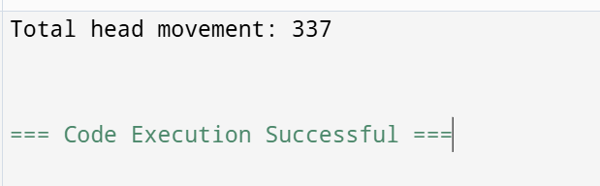

39)

#include <stdio.h>

#include <stdlib.h>

int main() {

int requests[] = {176, 79, 34, 60, 92, 11, 41, 114};

int head = 50, total_head_movement = 0, size = sizeof(requests) / sizeof(requests[0]);

int i, j, temp, seek_sequence[100], index = 0;

for (i = 0; i < size - 1; i++)

for (j = 0; j < size - i - 1; j++)

if (requests[j] > requests[j + 1]) {

temp = requests[j];

requests[j] = requests[j + 1];

requests[j + 1] = temp;

}

for (i = 0; i < size; i++)

if (requests[i] >= head) break;

for (j = i; j < size; j++) {

total_head_movement += abs(requests[j] - head);

head = requests[j];

seek_sequence[index++] = head;

}

total_head_movement += abs(head - 199);

head = 0;

total_head_movement += abs(199 - head);

for (j = 0; j < i; j++) {

total_head_movement += abs(requests[j] - head);

head = requests[j];

seek_sequence[index++] = head;

}

printf("Total head movement: %d\n", total_head_movement);

return 0;

}

**OUT PUT:**

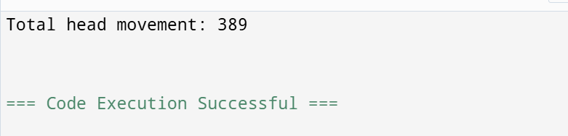

40)

#include <stdio.h>

int main() {

char *users[] = {"Owner", "Group", "Others"};

char *permissions[] = {"r", "w", "x"};

for (int i = 0; i < 3; i++) {

printf("%s: %s%s%s\n", users[i],

(i == 0 ? permissions[0] : "-"),

(i == 1 ? permissions[1] : "-"),

(i == 2 ? permissions[2] : "-"));

}

return 0;

}

**OUT PUT:**

